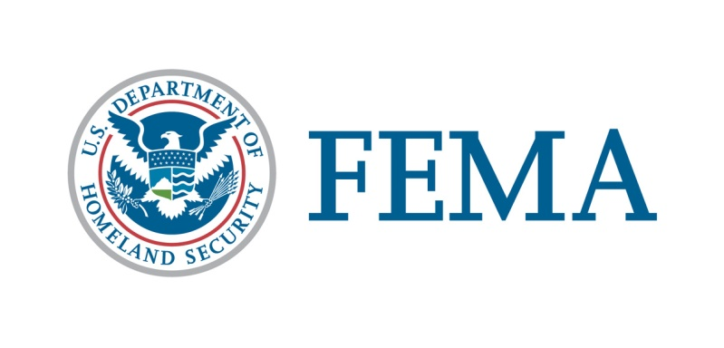

##### Congressional and Intergovernmental Affairs Division

202-646-4500

**State of Alabama**

**Federal Disaster Declaration Fact Sheet**

**March 29, 2020**

Today, March 29, 2020, President Donald J. Trump granted a Major Disaster Declaration for the State of Alabama triggering the release of Federal funds to help communities recover from COVID-19 that occurred January 20, 2020, and continuing.  Details of the disaster declaration and assistance programs are as follows:

Declaration Number:                                                              FEMA-4503-DR

Incident:                                                                                  COVID-19

Incident Period:                                                                      January 20, 2020, and continuing

Federal Coordinating Officer:                                                Gracia B. Szczech

Individual Assistance (IA):                                                       (Assistance to individuals and

households):

IA-Designated Areas:                                                                Under Review.

Public Assistance (PA):                                                          (Assistance for emergency work and

the repair or replacement of disaster-

damaged facilities):

PA-Designated Areas:                                                                Emergency protective

measures (Category B)

not authorized under

other Federal statutes,

including direct

federal assistance,

under the Public

Assistance program at

75 percent federal

funding for all areas in

the State of Alabama.

Hazard Mitigation (HM):                                                          (Assistance for actions taken to

prevent or reduce long term risk to

life and property from natural

hazards):

HM-Designated Areas:                                                              Under Review.

OTHER:                                                                                      Additional designations may be made

at a later date if requested by the

and warranted by the results of further

assessments.

###